Cannon SFML – Tutorial 04

Specification
- ASSESSED the simpleMotion sample is missing a cannon ball, if you look in the cannon.png texture you can see the sprite for it.
  - Game.cpp and Game.h contain multiple classes and it’s messy, break them out into separate cpp/h files.
  - Look at SFML’s sf::Vector2f type, then modify the Vec2f we have defined so you can use it everywhere, add constructors and operators as necessary to get an elegant solution that works in a similar way to sf::Vector2f, but under our control. The ability to elegantly convert between Vec2f and sf::Vector2f should be included. You could include handy functions to capture common behaviour as described above.
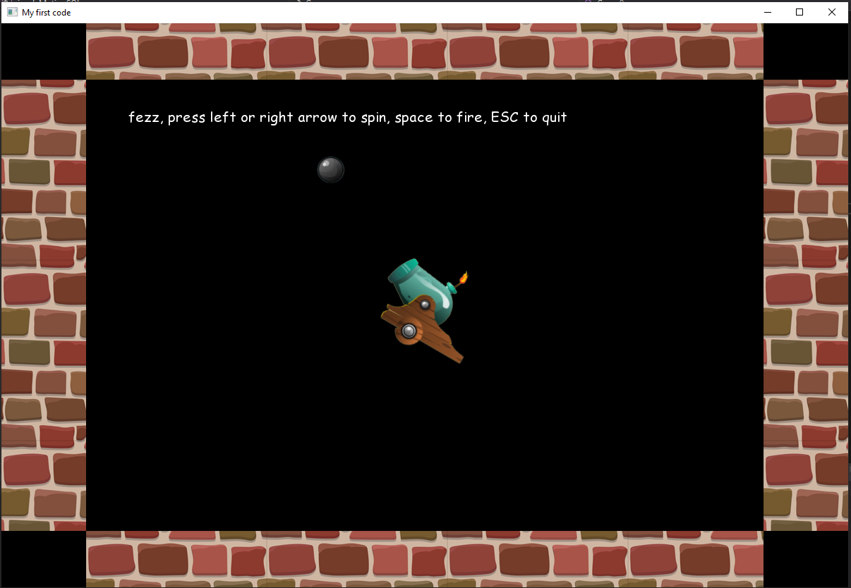
  - Add a cannon ball (inherit from GameObj) that you can fire out of the cannon and it bounces around inside the walls. There should only be one cannon ball instance. Pressing fire repeatedly makes the cannon ball just restart back at the cannon. It moves in a straight line, bouncing off the four walls forever (unless you press fire again). The ball appears at the end of the cannon and flies off in the direct the cannon points.
  - Produce the usual design docs, brief in this case as it’s not a major modification of the code, don’t forget to evidence you are using GiT.
Competencies: 1.1,1.2,1.6,1.7,1.8.1,1.8.4,1.8.3,1.8.4,1.8.5,1.8.6,1.8.7,1.8.8,1.8.9, 2.1,2.3,2.6.1,2.6.2

Game Design
Overview
The player rotates the cannon and shoots the cannon ball
Rules
This is a demo so there are not proper rules
Gameplay
The player uses left and right arrow keys to rotate the cannon
The player shoots the cannon
There can only be one cannon ball
The cannon ball bounces off the walls

Technical Design
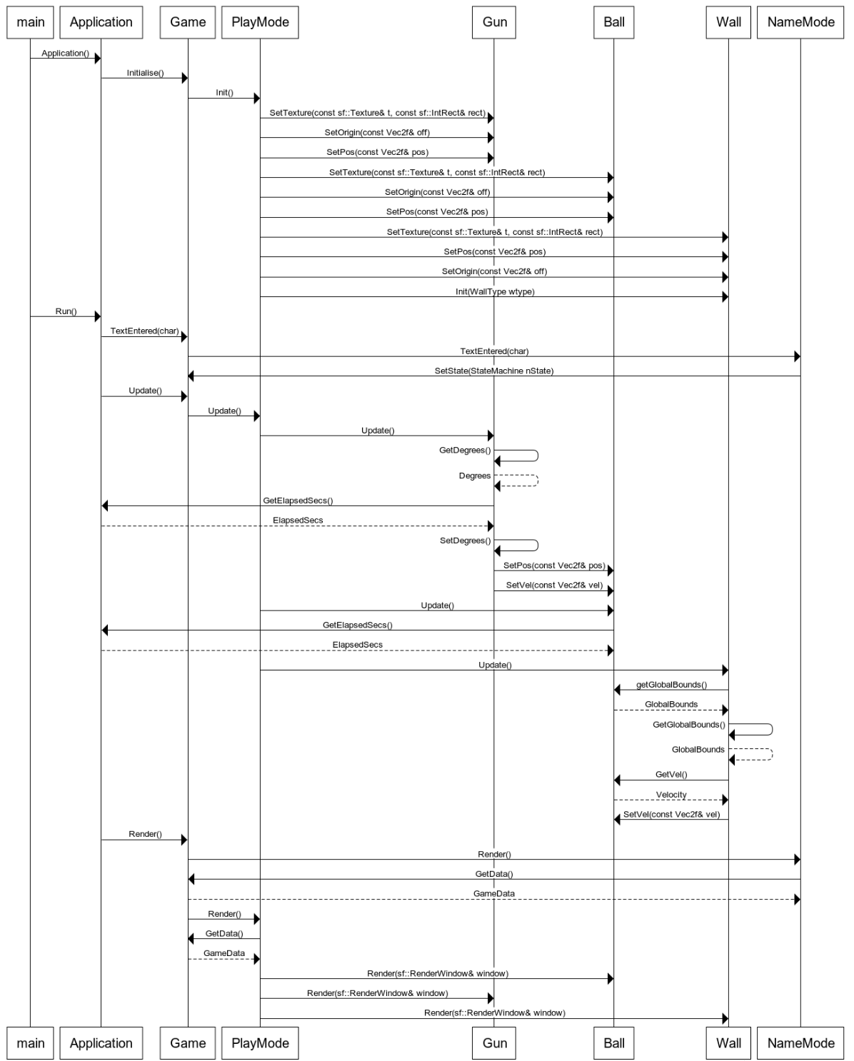
*Also see class diagrams found in the same directory as this document

Test Plan
State | Expected | Actual
Get_name | Player enters their name and presses enter to begin | Ok
play | Player presses the left and right arrow keys to rotate the cannon | OK
play | Player presses esc to exit the game | OK
play | Player presses space to fire the cannon ball | OK
play | There can only be one cannon ball and it resets when the player presses space | OK
play | The cannon ball bounces off the walls | OK

Git commit log
